Cloning a repo from Github

1. Go to <https://github.com/FreeSchemaInc>
   1. Organization github profile
   2. 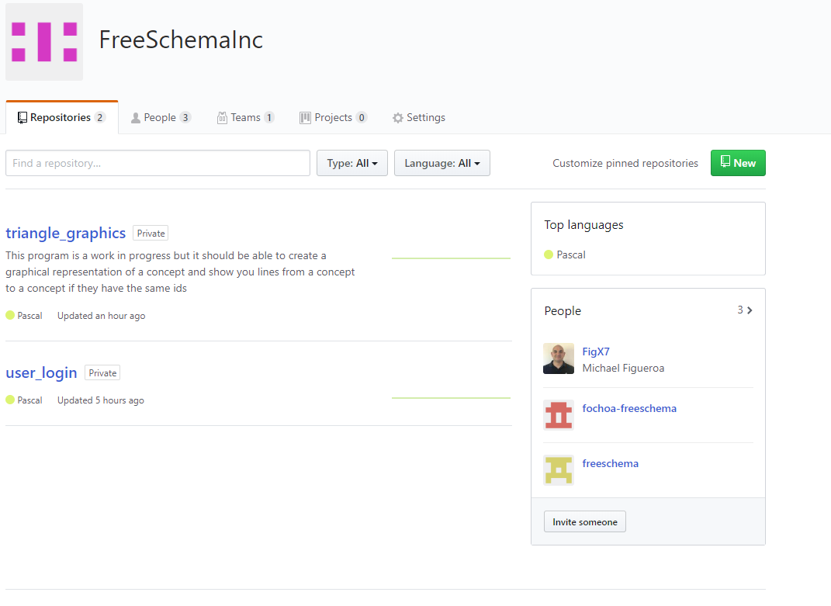
2. Choose repository you want to get from organization github account
   1. 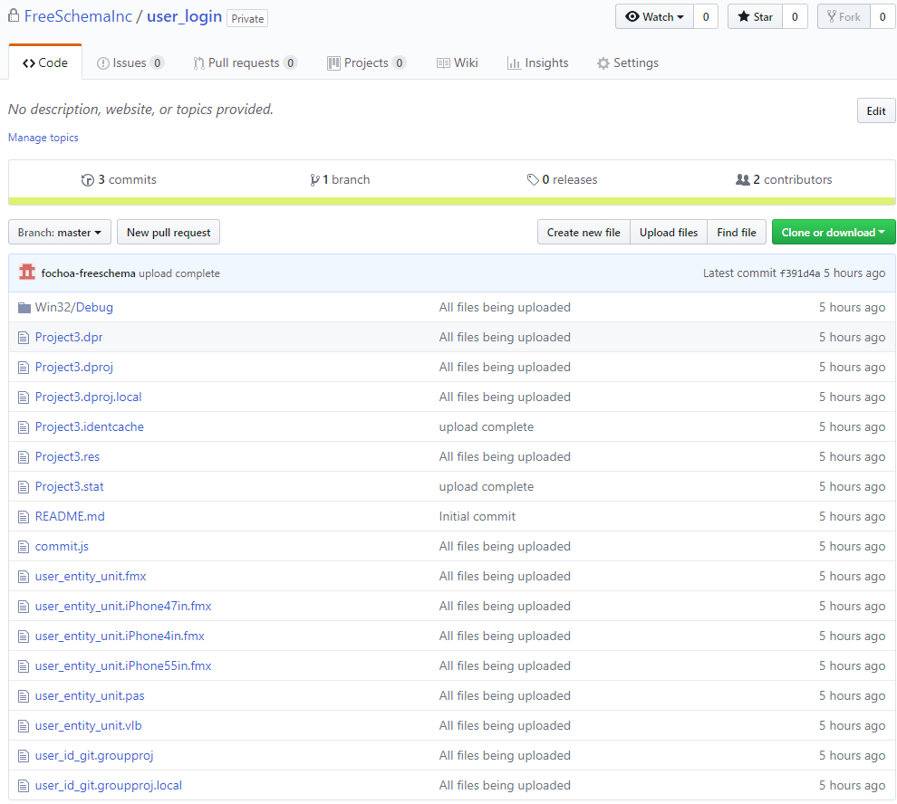
3. Click on the green clone or download button
   1. 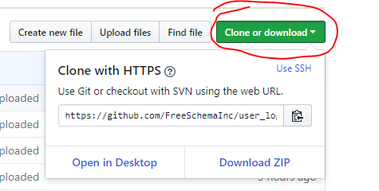
   2. Copy the link onto your clipboard
4. Create a folder in your local directory to clone the repository files to
   1. i.e. C:\Users\jd100\Documents\pancho_record\delphi_projects\Git\user_login
5. Start GitBash
   1. 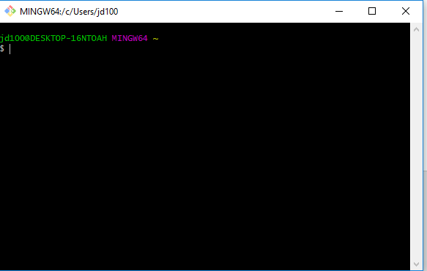
6. Locate file directory for the folder you just made using Gitbash
   1. 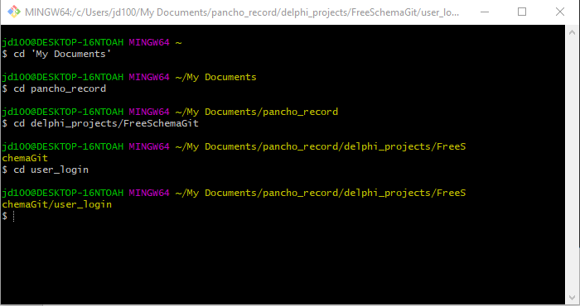
7. Clone Repository to local directory
   1. 